**КИЇВСЬКИЙ КОЛЕДЖ ЗВ´ЯЗКУ**

Циклова комісія "Комп’ютерної інженерії"

**ЗВІТ** **ВИКОНАННЯ**

**ПРАКТИЧНОГО ЗАВДАННЯ №2**

з дисципліни: «Введення до Інтернету речей»

Виконав студент

групи РПЗ-94

Нємєчкін М.Д.

Макаренко Д.А.

Перевірив викладач

Повхліб В.С.

Київ  2022

**Практичне завдання – Карта інтернету**

**Цілі та задачі**

**Part 1: Testing Network Connectivity Using Ping**

**Part 2: Tracing a route to a remote server using Windows Tracert**

**Part 2: Tracing a route to a remote server using Windows Tracert**

**Part 4: Compare Traceroute results**

**Scenario**

Using an Internet connection, you will use three types of tracing to explore the Internet path to destination networks. This action must be performed on a computer with Internet access and access to a command line. First, you'll be using built-in Windows traffic. Second. you will use this tool http://www.subnetonline.com/pages/network-tools/online-traceroute.php Finally, you will use VisualRoute's traceroute program.

Required resources

1 PC with internet access

**Performed by Maxim Nemechkin**

* 1. **Test your network connection with Ping**
  2. Determine if the remote server is available.
     1. In the command line, enter **ping** [**www.cisco.com**](http://www.cisco.com).

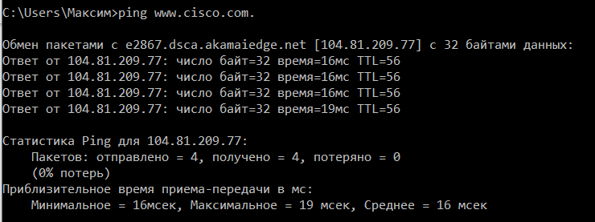

A more accurate determination of the speed of the Internet connection can be determined by sending 100 pings instead of the default 4. Here's how to do it:



Result:

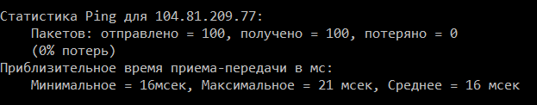

**Performed by Danya Makarenko**

* + 1. Now the websites of Regional Internet Registries (RIRs) located in different parts of the world:

For Africa:

C:\> **ping www.afrinic.net**

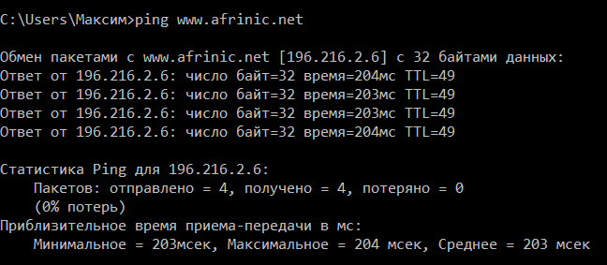

For Australia:

C:\> **ping www.apnic.net**

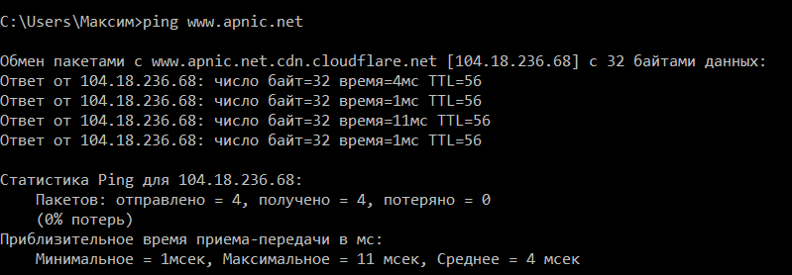

For Europe:

C:\> **ping www.ripe.net**

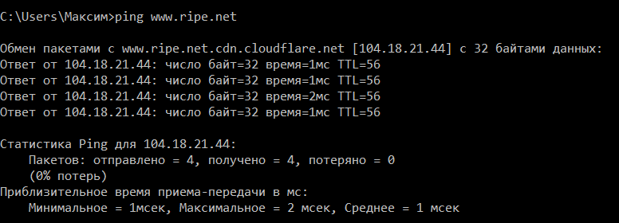

For South America:

C:\> **ping www.lacnic.net**

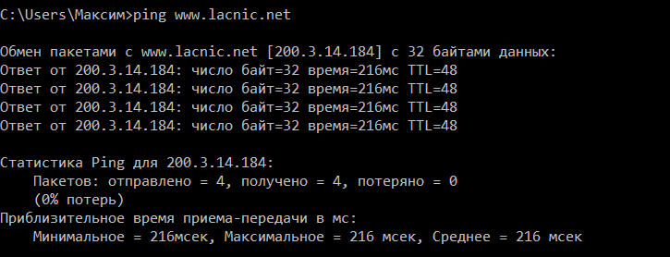

**What's interesting about the pings that were sent to the European website?**

Pings sent to European sites are interesting because they are delivered very quickly.

**Performed by Maxim Nemechkin**

* 1. **Trace a route on a remote server using Tracert**

Determine the route through Internet traffic to the remote server.

* + 1. At the command prompt, type tracert www.cisco.com .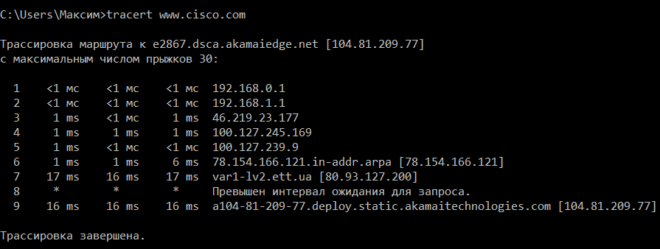
    2. Run tracert for each destination website and save the output in sequentially numbered files.

C:\> **tracert** [**www.afrinic.net**](http://www.afrinic.net)

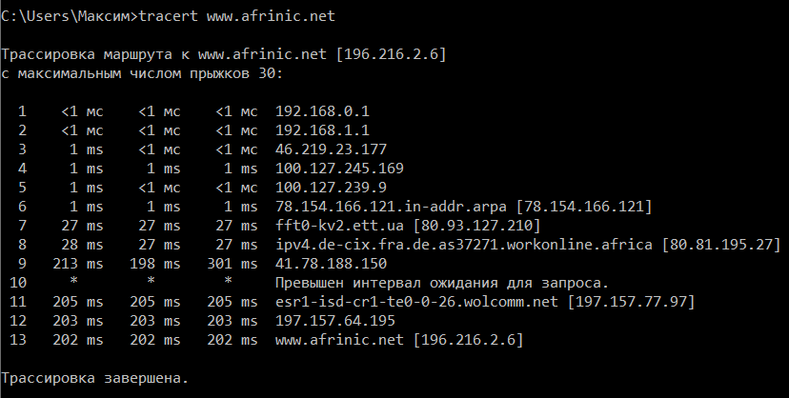

***What's happening at 7 hop? Is level3.net the same ISP as hops 2-6 or is it a different ISP? Use the Whois tool to answer this question.***

On the 7th hop, the IP address changes because a new provider is found to go to. They differ in that the provider for hops 2-6 is Verizon GNI - IP System Operations, and the provider for hop 7 is Level 3 Communications, LLC.

***What happens at hop 10 in the time it takes to travel a packet between Washington and Paris compared to hops 1-8?***

Due to the physical distance, the packet transmission time increased. Since the user is located in the USA, the transfer of packets was faster than after switching to European providers.

***What's happening at hop18? Do a Whois lookup for 168.209.201.74 using a Whois tool. Who owns this network?***

In hop 18, it reached the afrinic.net POP router. The owner is the organization AfriNIC Ltd.

Enter  **tracert www.lacnic.net** .

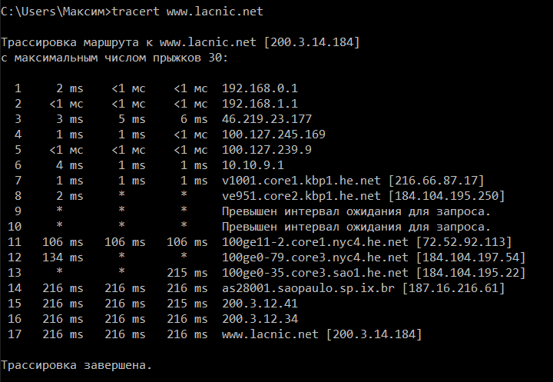

***What happens in hop 7?***

The tracert packet reaches the registro.br POP router located in Brazil.

**Track the route on a remote server using web and software tools**

**Use the traceroute web tool.**

**Performed by Danya Makarenko**

* + 1. Use http://www.subnetonline.com/pages/network-tools/online-tracepath.php to trace the route to the following websites:

[www.cisco.com](http://www.cisco.com)

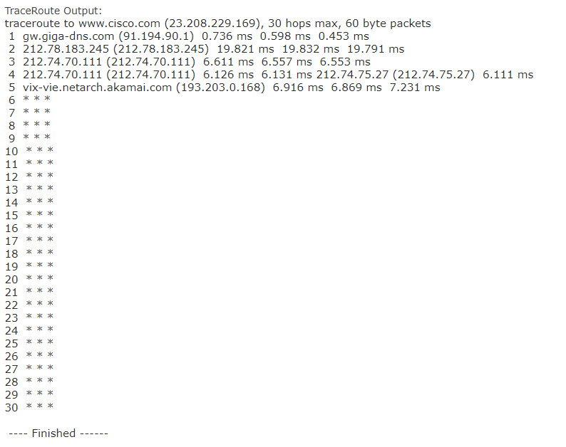

[www.afrinic.net](http://www.afrinic.net)

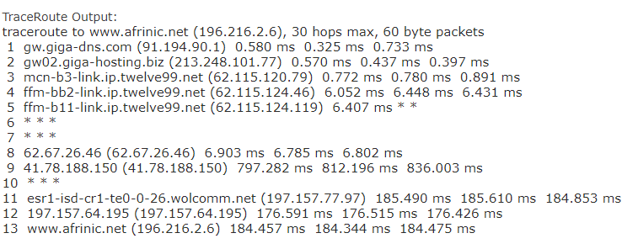

***How does traceroute differ when going to www.cisco.com from the command line and not from the website? (Your results may vary depending on where you are geographically and which Internet service provider connects you.)***

Tracert from the command line was querying my service provider to get to www.cisco.com. Tracking from the website takes place from the server of this website. But the site could not meet the transition limit and the package did not reach the target site.

***Compare the tracert from part 1 that goes to Africa with the tracer that goes to Africa from the web interface. What is the difference?***

Fewer conversions were made from the website than from the console. When tracing from the console, the packet transfer also goes through the local provider, while the website traces from the server on which it is hosted.

***Some of them contain the abbreviation asymm . Any guesses as to what that means? What is its meaning?***

"assim" is short for "asymmetry", which means "asymmetric". This means that the route is asymmetric, that is, from us to the node and from the node to us, the packet goes through different paths.

**Performed by Maxim Nemechkin**

**Use VisualRoute Lite Edition.**

Path to www.cisco.com using tracert: 9

Path to www.cisco.com using the web tool at

subnetonline.com: <30

List the path to www.cisco.com using VisualRoute Lite edition: 10

VisualRoute and tracert use the same paths except that VisualRoute also considers the device itself. And so they both make their way through the POP routers of the local provider and then through the global one.

subnetonline.com in turn starts the path from its server and routes the path relative to it. Perhaps due to ping blocking, this method does not work and we see that the trace packet reaches its limit of existence

**Performed by Danya Makarenko**

**Consideration:**

Unlike the other two presented methods, VisualRoute provides a convenient visual interface with an accessible presentation of information and display of host positions. It is also more convenient to track peering points. What stands out the most is a short path analysis that provides an overview of speed and connection status.